**POWER BI ASSIGNMENT – 1**

1).REPORT VIEW:-

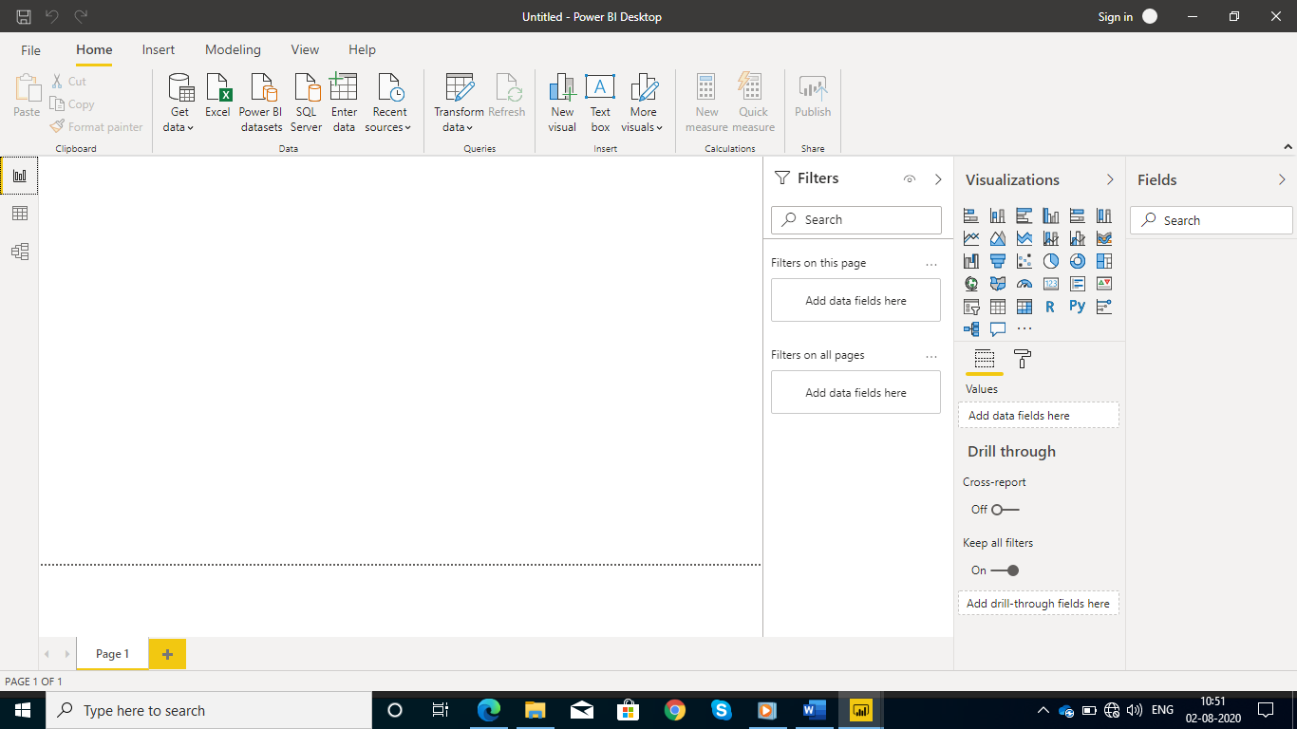

2).DATA VIEW:-

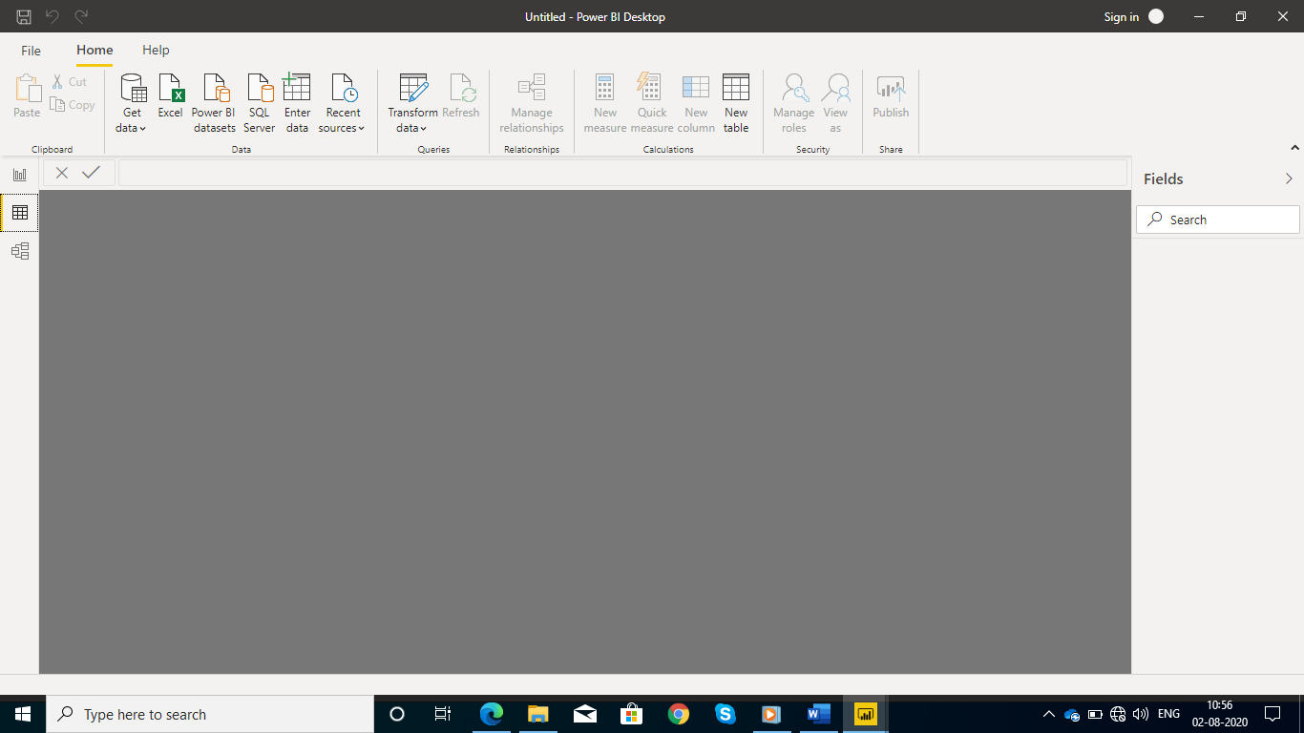

3).MODEL VIEW:-

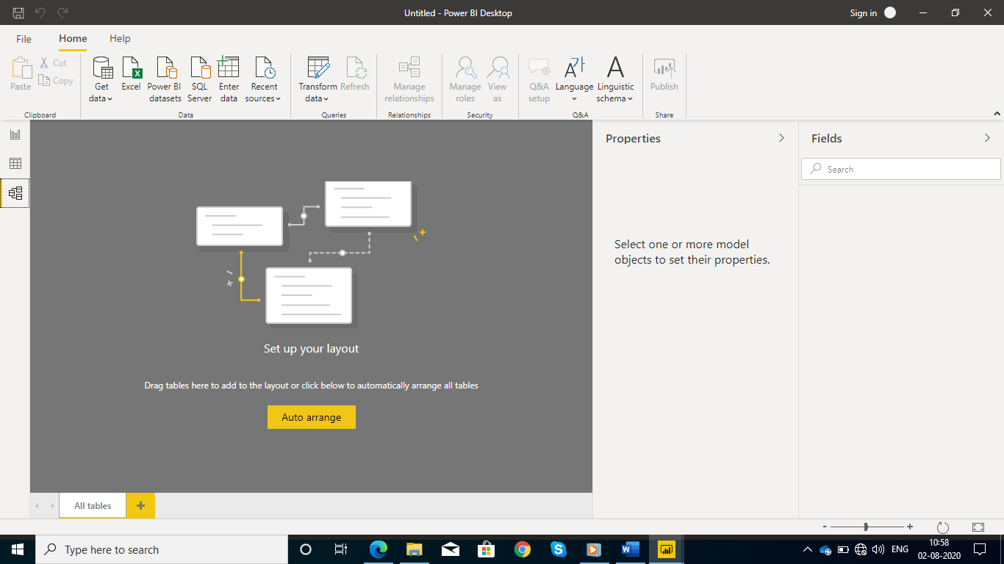

4).POWER QUERY EDITOR:-

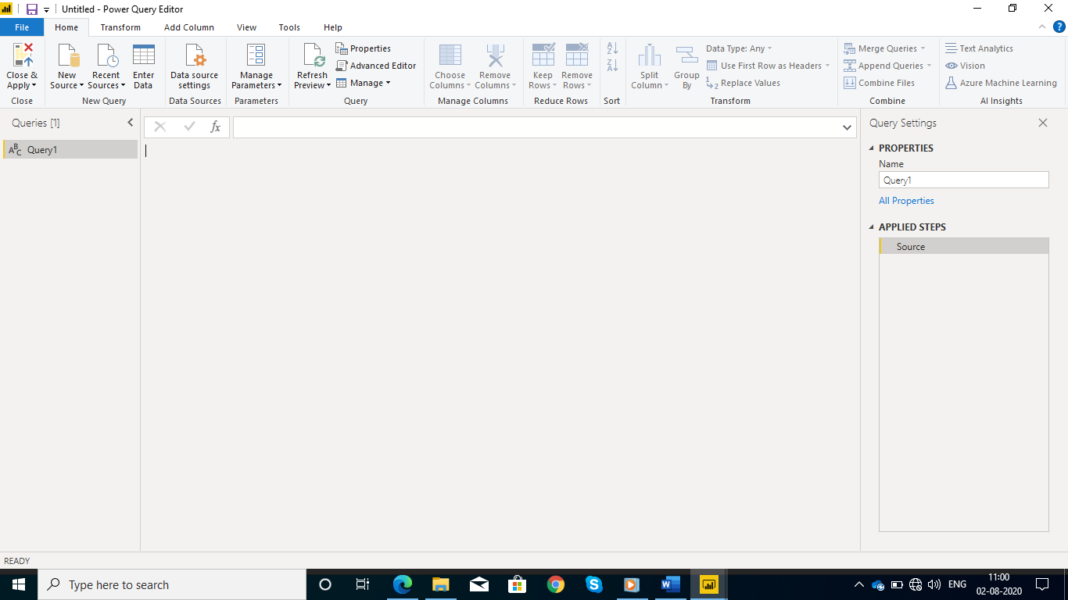

5).ADVANCE EDITOR:-

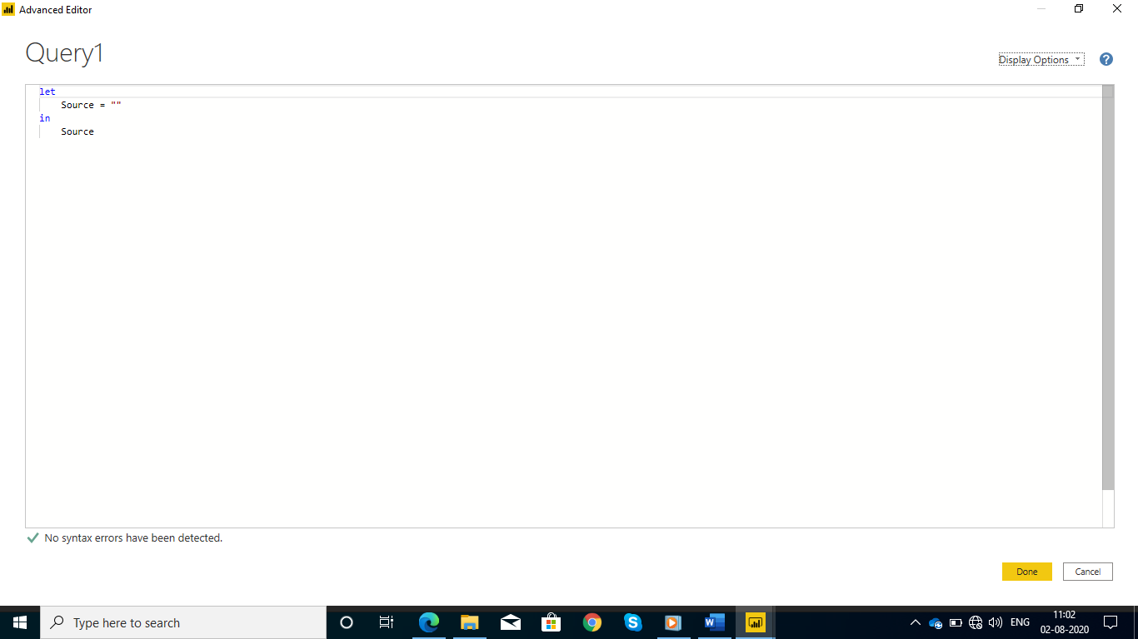

Power bi prices:-

